What is natural selection?

You will begin to learn about natural selection by analyzing the changes in a population of mice that lived in a desert with gray sand. These drawings show how the population changed from time 1 to time 3.
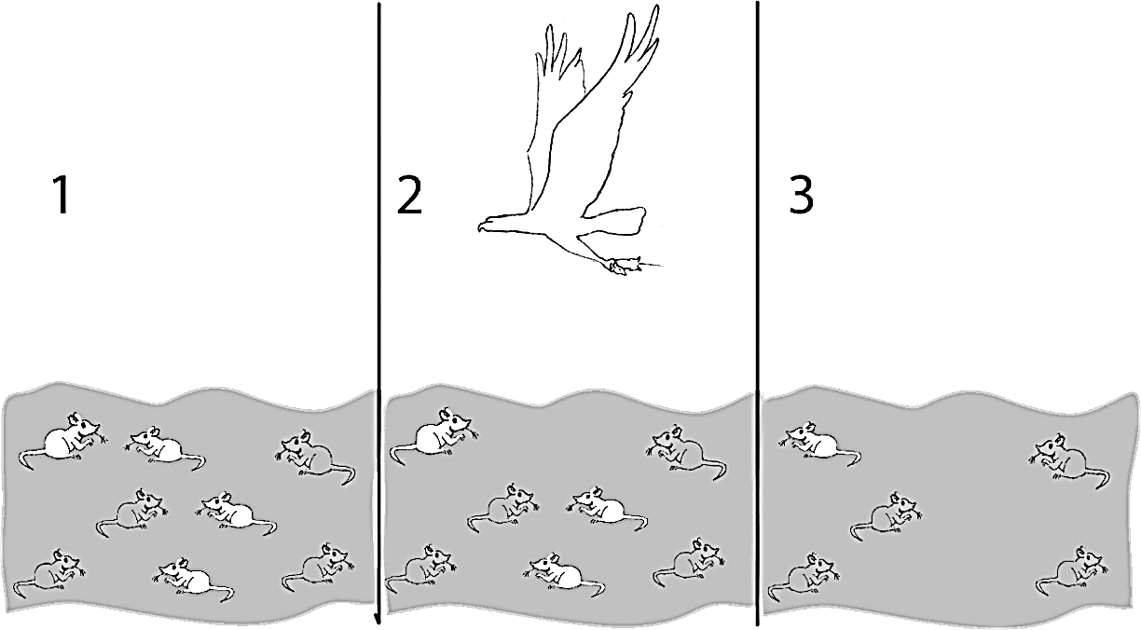

1a. Describe how the population of mice changed from time 1 to time 3.

1b. Explain what happened to cause this change.

2. Fitness is defined as the ability to survive and reproduce. For the mice in the figure, which characteristic increased fitness?

3. The term fitness can have different meanings, depending on what subject you are discussing.

What does the term physical fitness mean?

What does the term fitness mean when biologists are discussing evolution?

Biologists released three pairs of adult mice in a gray sand desert; these Generation 1 Adults are shown in the first row of this figure. These mice had the babies shown in the second row. The babies that survived to become the Generation 2 Adults are shown in the last row.

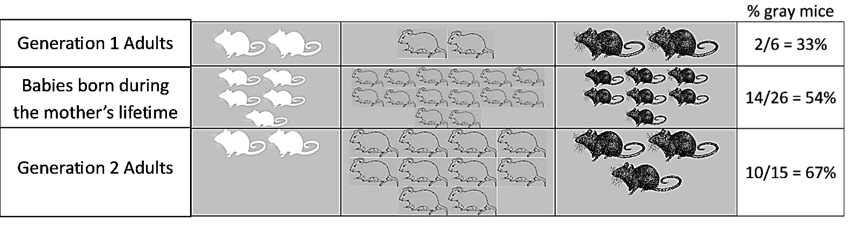
This table shows some characteristics of the Generation 1 adult females.

Color of Fur | White | Gray | Black
Number of babies born | 5 | 14 | 7
Age at death | 3 months | 7 months | 4 months

4. Give a likely reason why the female with gray fur had the most babies. (Hint: Female mice can have a litter every month after they begin having babies at age 2 months.)

- A heritable characteristic is influenced by genes and passed from parents to offspring. For example, fur color is a heritable characteristic for mice.
- An adaptation is a heritable characteristic that increases fitness (the ability to survive and reproduce).

5a. Which color fur is an adaptation for the mice in the gray sand desert?

5b. What evidence (from the figure near the top of this page) supports your answer?

5c. The percent of adults with gray fur increased from 33% in Generation 1 to 67% in Generation 2. What caused this increase?

6a. Predict what would happen to this population of mice after many generations on the gray sand.
- About two-thirds (67%) of the mice would have gray fur.
- Almost all of the mice would have gray fur.
- There would be equal numbers of mice with white fur, gray fur, and black fur.

6b. Explain your reasoning.

7. Explain how an adaptation becomes common in a population. (Remember that an adaptation is a heritable characteristic that increases fitness.)

Natural selection causes an adaptation to become common in a population. The adaptation becomes common because:
- An adaptation increases fitness, so individuals that have this characteristic are more likely to survive and reproduce.
- An adaptation is heritable, so the offspring generally have the same characteristic.

8. Evolution is defined as a change over time in the inherited characteristics of a population. What is evolution by natural selection? (Hint: A complete answer will include adaptations, fitness, and heritable.)

9. Explain why organisms have many characteristics that help them survive and reproduce in their environment.

10a. Does natural selection produce the same result in different environments? (Hint: Think about mice on gray vs. white sand.) yes ___ no ___
10b. Explain your reasoning.

Necessary Conditions for Evolution by Natural Selection

You will analyze two hypothetical scenarios to learn about the conditions that are needed for evolution by natural selection to occur.

Suppose that three pairs of white mice migrated to a desert with gray sand. The owner of the gray desert dyed the fur of one pair gray and one pair black.

11a. Think about the Generation 2 Babies of these Generation 1 Adults. What proportion of the babies do you think would be born with gray fur?
none ___ about 33% ___ about 54% ___ about 67% ___ at least 90% ___

11b. Explain your reasoning.

11c. Explain why evolution by natural selection only occurs if variation in a characteristic is heritable.

Next, suppose that a pair of white mice, a pair of gray mice, and a pair of black mice migrated to a desert with gray sand. The owner of this desert had a special fondness for mice, so she had eliminated all of the predators that ate mice. Therefore, white, gray and black mice all had the same probability of surviving and reproducing.

12a. Would the proportion of gray mice on this gray sand desert change in the next generation? decrease ___ increase ___ stay about the same ___

12b. Explain your reasoning.

12c. Based on this example, explain why evolution by natural selection can only occur if the variation in a characteristic results in differences in fitness.

13a. Evolution by natural selection occurs in all types of organisms. What is the adaptation for cacti in the example of natural selection shown in these pictures?

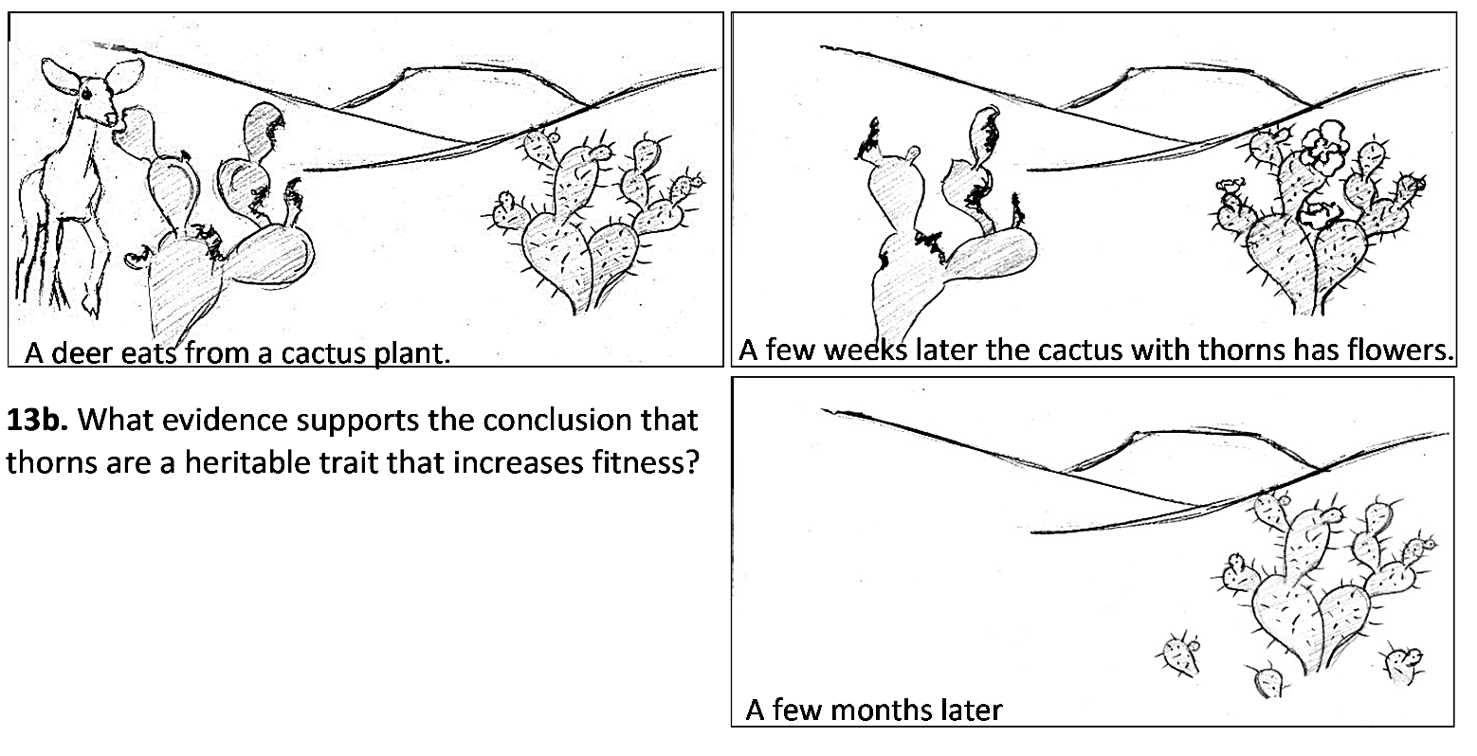

13c. Complete the following table to describe the conditions needed for evolution by natural selection to occur and the evidence that the cactus example meets these conditions.

Condition Needed for Evolution by Natural Selection to Occur | Evidence from the Pictures that this Condition is True  for Thorns in the Cactus Example

By Dr. Ingrid Waldron, Biology Dept, University of Pennsylvania. © 2026. This Student Handout and Teacher Notes (with background biology and instructional suggestions) are available at https://serendipstudio.org/exchange/bioactivities/NaturalSelectionIntro.

